Questions for Reflection / Discussion / Sharing
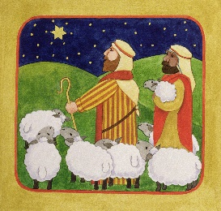
- What new things may be surfacing in your work as a board?

- Do you welcome this newness as promising, or see it as a challenge?

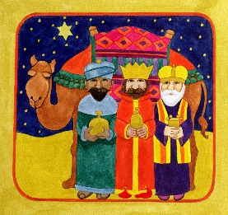
- As you look at the work of your board and your particular
role on the board, what requires your tenderness?
Your hope?
What requires you to set out, and get on your way?

- To engage this newness, what do you need from the other board members?
From God?
What do you need to do for yourself?
Credits:
The Shepherds © Linda Benton, Bridgeman Art Library. Used with permission
Three Kings and Camel © Linda Benton, Bridgeman Art Library. Used with Permission

Questions for Reflection / Discussion / Sharing
- What new things may be surfacing in your work as a board?

- Do you welcome this newness as promising, or see it as a challenge?

- As you look at the work of your board and your particular
role on the board, what requires your tenderness?
Your hope?
What requires you to set out, and get on your way?

- To engage this newness, what do you need from the other board members?
From God?
What do you need to do for yourself?
Credits:
The Shepherds © Linda Benton, Bridgeman Art Library. Used with permission
Three Kings and Camel © Linda Benton, Bridgeman Art Library. Used with Permission

