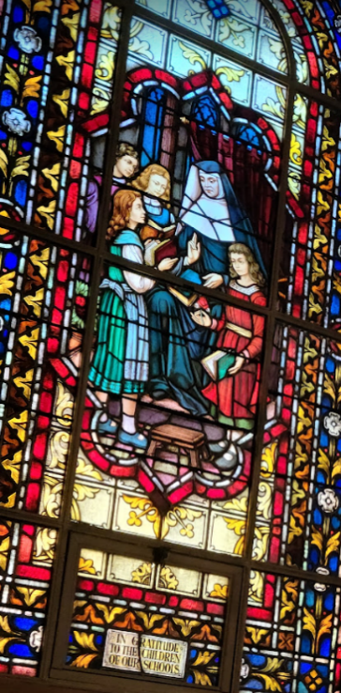
Questions for Reflection / Discussion / Sharing
- What does the word ‘transition’ evoke in you?
- In light of changing circumstances due to the pandemic and/or other realities, how might your ministry have been thrust into a transition? How do you feel about this?
How might the board as a whole navigate this transition? What might be your specific contribution? What might you need?
- How do you and your board consider deepening and/or focusing your commitment to mission? What resources do you have? What else might you need?
- How might the work of transition and the work of mission be connected/intertwined?

Questions for Reflection / Discussion / Sharing
- What does the word ‘transition’ evoke in you?
- In light of changing circumstances due to the pandemic and/or other realities, how might your ministry have been thrust into a transition? How do you feel about this?
How might the board as a whole navigate this transition? What might be your specific contribution? What might you need?
- How do you and your board consider deepening and/or focusing your commitment to mission? What resources do you have? What else might you need?
- How might the work of transition and the work of mission be connected/intertwined?

