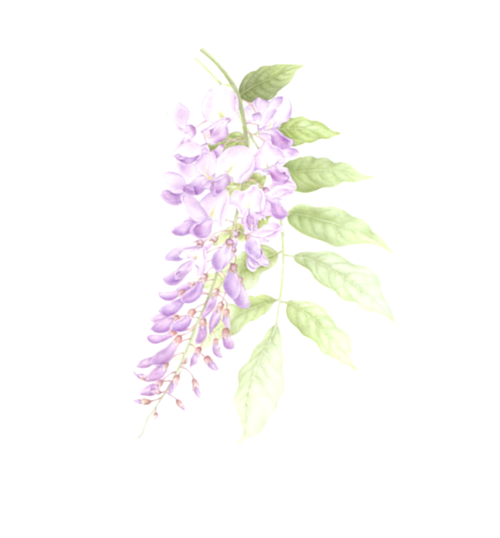

When You Pray

When you pray, be like the mountain in stillness, in silence;
thoughts rooted in eternity. Do nothing; just sit, just be;
and you will harvest the fruit of your prayer.

When you pray, be like the flower reaching up to the sun;
straight-stemmed like a column.
Be open, ready to accept all things without fear and you will not lack light on your way.

When you pray, be like the ocean
with stillness in its depths
the waves ebbing and flowing.
Have calm in your heart, and evil thoughts will flee on their own accord.

When you pray, remember the breath That made us living beings-
From God it comes; to God it returns.
Blend the Word and prayer with the flow of your life, and nothing will come between you and the Giver of Life.
When you pray, be like the bird,
endlessly singing before the Creator its song rising like incense.
Pray like the turtle dove, and you will never lose heart.

When you pray, say
Creator God in heaven, Holy is your name.
May your reign come on earth as it is in heaven.
Give us today the bread we need.
Forgive us our sins as we forgive others.
Lead us not into temptation but deliver us from all evil.

O Holy Spirit, inspire us with wonder and awe at the mystery of your presence. Confirm us in your wisdom in times of confusion. Grant us discerning hearts in making decisions.

(St. Seraphim of Sarov)

Department of Ministry Services, Atlantic-Midwest Province

