Celebrate
the
185th Anniversary of the
School Sisters of Notre Dame
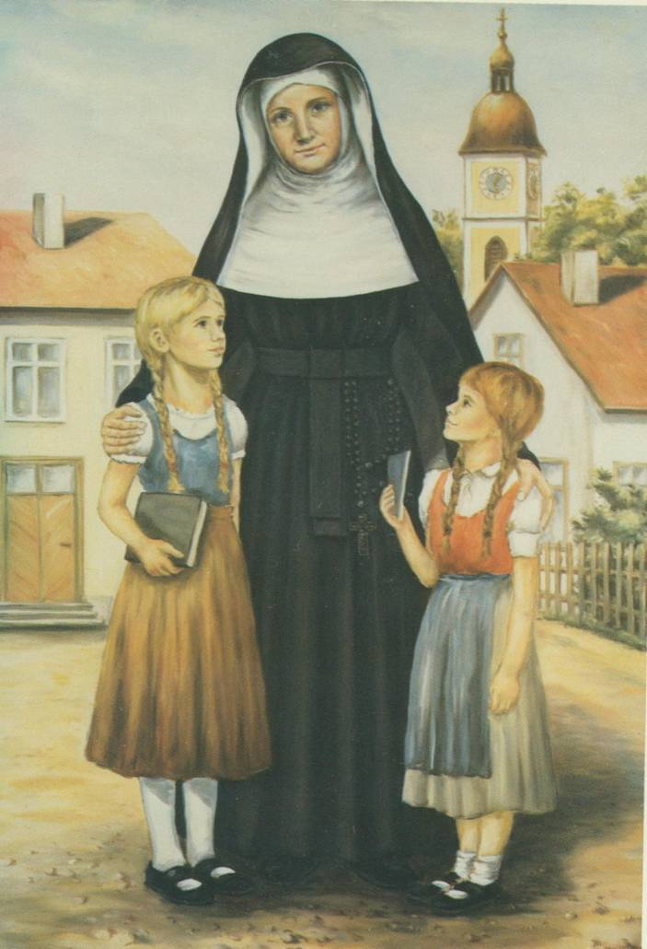

In Service to the People of Rochester for 165 years

Sunday, October 28th
Sacred Heart Cathedral
Mass at 1:30 pm
Reception to Follow in Narthex

Transforming the World through Education

